Preferred Options for Housing in Church Stretton

To: The Strettons Civic Society
From:
Date: 7th December 2018
RE: CSTO 21 Snatchfield Farm 4.29 Ha; Approximate capacity 70 dwellings

The following observations are made in relation to the proposed development of additional housing at Snatchfield Farm.

(1) Access to the Proposed Site
Problems of access goes well beyond the question of immediate access to the development via Chelmick Drive and the demolition of one bungalow.
Clive Ave is currently a danger bottleneck: the carriageway for much of its length fluctuates between 4.5 and 4.7 metres and there is NO pavement or pedestrian walkway. The road can be too narrow for cars to pass each other and pedestrians have to lean into the hedge in order to ensure their own safety and allow traffic to pass. Larger vehicles present a more serious concern.
A number of residents using mobility scooters already face considerable anxiety for their personal safety using Clive Avenue. Schoolchildren also have to use this carriageway. Pedestrian visitors to Gough’s Coppice and Ragleth Hill further add to the footfall. It should be noted that this road is very steep and prone to heavy frost/freezing making conditions slippery for pedestrians and vehicles - and to remain safe and out of each other’s way. Last winter vehicular access for houses up Ragleth Road was impossible due to freezing temperatures. Also, underground water flow from Ragleth Wood is significant and caused a large sink hole on Ragleth Rd and road buckling at the bottom of Clive Av. Additional traffic will only magnify these problems.
Clive Avenue is a choke point and provides the only access (effectively to one large cul-de-sac) for about 120 properties. The historical development of housing beyond this point presumable did not account for the increase in the number and size of vehicles that would use this country lane. The prospect of the additional development of a further 70 households, all increasingly dependent on such a narrow thoroughfare, must raise concerns for the future of vehicular and pedestrian safety. Development in Snatchfield would increase the number of households dependent on Clive Avenue to about 200. In short, a poorly lit, unpaved lane 4.5 metres wide would have to meet the following need:
- heavy construction traffic and plant machinery for an lengthy period of time during the development phase
- the longer term need of domestic traffic from over 200 households (probably in excess of 500 residents including schoolchildren, the elderly and those dependant on mobility devices
- a rise in ongoing heavy traffic associated with the servicing requirements of the area, for example; highways and utilities; refuse collections; delivery vans and trucks – of which there has been an exponential rise in recent years).
(2) Area of outstanding beauty – environmental and recreational impact
That Church Stretton is situated in an Area of Outstanding Natural Beauty is well documented in previous discussions on further development. And that the Council has a responsibility to not only conserve, but ‘enhance’ this valuable legacy remains paramount.
Snatchfield specifically is bisected by the Jack Mytton Way. Mention of ‘buffering’ and ‘sympathic landscaping’ to protect this as a requirement of any development seems little more than wishful thinking. It is inconceivable that this principal pathway to the Ragleth, Hazler and Hope Bowdler Hills will not be diminished by enclosing it within a major housing development. Currently, this routeway offers perhaps the most significant access to the hills on the eastern side of the town and is used by countless rambling groups and significant numbers of young expedition groups (such as D of E) – not forgetting large numbers of town residents.
Snatchfield offers almost immediate access to the countryside from the town, in much the same way as Rectory Wood to the west. There is little doubt that the experience of visiting the ‘eastern hills’ from Church Stretton will be diminished both during the construction phase and beyond.
Similarly, the unspoilt rural approach into town (for those descending through Snatchfield) which is unparalled, will be swept away. For some of our elderly residents whose mobility is now very limited, the walk to Snatchfield farm and back is one of few opportunities to access and engage with a countryside experience. It will be a grave disappointment for them to lose this small remaining freedom.
Others will no doubt be able to reflect in more detail about the natural characteristics of Snatchfield. However, I can add that there has been a disturbing reduction in bird populations throughout the area. Local breeding bird surveys show a worrying decline in species, particularly on intensified farm land either side of the A49 but indeed also on the Long Mynd. The rough grazing and wet flushes of Snatchfield provides some respite from intensification. Breeding birds here include buzzard, sparrowhawk and tawny owl, so the predatory nature of these species is testament to the value of the other species upon which they rely.
There was good reasoning behind the designation of the this AONB centred on Church Stretton and it is hoped that the principles guiding the safeguarding of this designation for the future can to maintained.
I hope these observations are in part helpful.
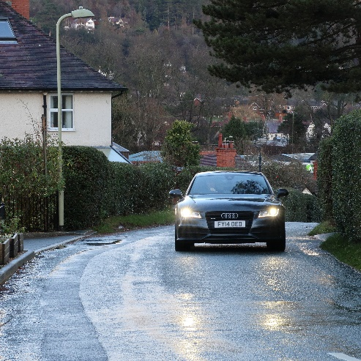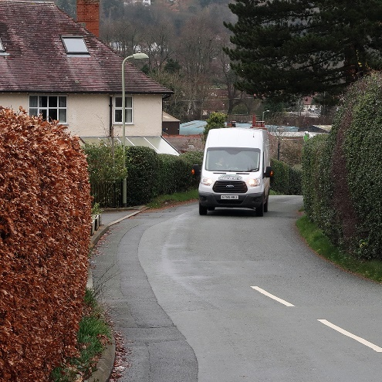
Pedestrian eye view of the walk down Clive Ave

